Stability
FreeBSD is held in high esteem by experts for being rock-solid, a system that remains responsive even under highest loads.
FreeBSD maintains stable kernel interfaces within major releases and is compatible to its predecessors if you activate this feature. Opera e.g., ported to FreeBSD 4.6, also runs on FreeBSD 6.0. This stability is extremely valuable to companies issuing device-drivers or using a proprietary distribution model.
If you consider a long uptime as a benchmark of a stable system, then FreeBSD is the undisputed top contender. The corporations mentioned also require high stability, the smallest outage can cost an enormous amount of money, to avoid this they use FreeBSD.
Applications
FreeBSD has over 16'000 Ports with a huge selection of free (beer and source) applications. A growing amount of proprietary applications like Oracle is supported too.
Philosophy
FreeBSD, in contrast to other free operating systems, does not evangelize a political or ideological message. The sole aim is to give the user greatest freedom and stability with the code.
FreeBSD is the love for UNIX, clean, stable, fast code and the freedom of the individual. Nothing expresses this better than the BSD license common to all BSDs. Except for the obligation to mention the origin of the code, everyone is free to do with it whatever she or he wants.
Whether as a corporation or as a private person, free or proprietary, source or binary, the user alone decides. FreeBSD is a gift to humanity - we're happy if you use it.
History
FreeBSD shares more than 30 years history with its ancestors, dating back to the year 1975. It originated at the University of Berkeley and evolved over time and multiple steps to the project founded in 1993 known as FreeBSD.

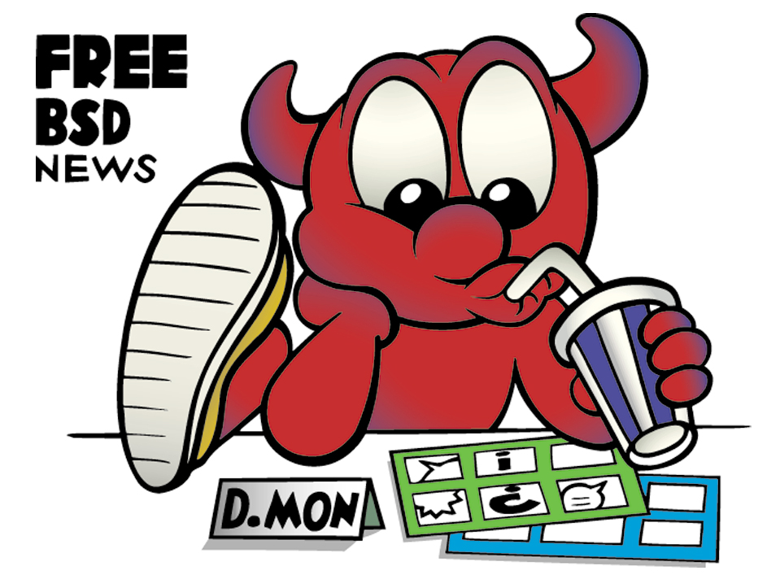
More Information
Important websites:
http://www.FreeBSD.org/
http://www.NetBSD.org/
http://www.OpenBSD.org/
http://www.DragonflyBSD.org/
Mailinglists, newsgroups:
http://www.freebsd.org/doc/en/books/handbook/
http://lists.FreeBSD.org/mailman/listinfo
http://www.BSDForums.org/
de.comp.os.unix.bsd
Other FreeBSD-projects:
FreeSBIE: http://www.FreeSBIE.org/
DesktopBSD: http://DesktopBSD.net/
PC-BSD: http://www.PCBSD.org/
pfsense: http://www.pfsense.org/
m0n0wall: http://m0n0.ch/wall/
FreeNAS: http://www.freenas.org/
Frenzy: http://Frenzy.org.ua/eng/
RoFreeSBIE: http://www.RoFreesbie.org/
We cannot possibly list all advantages of FreeBSD in detail on 2 pages. Other flyers are available to provide details. If you have any comment, critique or improvement to make, please don't hesitate and send a mail to Daniel.Seuffert@allBSD.de. Thanks a lot!

Why FreeBSD?
FreeBSD: Your advantages
What ist FreeBSD?
This flyer explains some advantages and basic principles of FreeBSD.
The Berkeley Software Distribution (BSD) is a free open source version of the operating system Unix, which evolved at the University of Berkely starting 1975. BSD is based on AT&Ts Unix Sixth Edition (V6). The name BSD is now used collectively for the modern descendants of these distributions.
Most notable among these today is perhaps the major open source BSDs (FreeBSD, NetBSD, OpenBSD, DragonFly BSD) which have themselves spawned a number of children. They are targeted at an array of systems for different purposes and are common in government facilities, universities and in commercial use. A number of commercial operating systems are also partly or wholly based on BSD or its descendants, including Apple Computer's Mac OS X.
FreeBSD is most widespread and known BSD because of his good hardware support and the number op applications (Ports) available. There are several FreeBSD distributions optimized for particular scenarios. We don't want to go into details here, please have a look at the links at the end of this flyer. There are DesktopBSD and PC-BSD optimized for desktop use and beginners, FreeSBIE is a livecd and toolset as well to create your own live media, m0n0wall and pfsense are used for routers and firewalls and Frenzy is a minimalist rescue and adminstration toolkit CD.
Here be FreeBSD
Embedded systems are currently a hot topic, did you know that there could be FreeBSD in your firewalls and routers?
In Nokia and Checkpoint firewalls you find FreeBSD code. Juniper Networks uses parts of FreeBSD for their Internet backbone routers. Also IBM, Intel and Coyote use code from the FreeBSD project.
If you use hardware from these companies, why not use FreeBSD, the source of this functionality, for your servers?
FreeBSD and the World Wide Web
Did you know that some of the largest corporations rely on FreeBSD to deliver Internet pages, offers and security?
This fact seems to be drowned out a little by the hype surrounding Linux. Surely you have come into contact with FreeBSD. Sony Japan, probably the best-known company for consumer electronics uses FreeBSD.
The globally known free mail and search portal company Yahoo! has been using FreeBSD for years. And NTT/Verio and Netcraft are also convinced FreeBSD is the best choice for them.
When globally represented corporations trust FreeBSD, maybe you could too.
FreeBSD, providing Internet Services
Nowadays all it needs is a click, and you're on the Internet without losing a thought. The ISPs behind this service use various systems to provide you with this access to the Internet.
Providers need to deliver reliable access to the Internet. Especially private customers are likely to change their provider when problems occur which leads to a loss of image and revenue. Seven of the nine most reliable providers therefore use and trust FreeBSD (Heise Newsticker 2004).
Corporations like UUNet, Pair, Demon and EasyNet have millions of satisfied customers all with the help of the operating system called FreeBSD.
FreeBSD and Multi Processor Systems
In the very near future multiprocessor or multicore systems will dominate even on desktops. FreeBSD started anticipating that development in 1998.
FreeBSD release 5.0 in 2003 introduced the so called SMPng (Symmetric MultiProcessing next generation). Today FreeBSD has excellent support for multiprocessor/ multicore systems.
FreeBSD Code in other Systems, in your
Applications even?
The wheel shouldn't be reinvented repeatedly, especially in times where development costs are rising more and more.
Mac OS X, considered by many to be one of the most advanced operating systems of our time regarding usability, security and freedom for the user, beneath the graphical user interface, is a FreeBSD modified by Apple.
The kernel is a Mach kernel with large parts from the FreeBSD project, the user land tools are all from Free-BSD (Apple calls its FreeBSD-variant "Darwin").
Microsoft too uses BSD code in their command line tools, used the BSD TCP/IP stack from Spider and the current "Services For Unix" are based on OpenBSD's code.
Using BSD code is possible without any problems by way of the BSD license, allowing you to use the code as you like, only requiring you to retain the original copyright notice.
You can also take advantage of this. Don't reinvent the wheel, use the current BSD code in your programs, use FreeBSD as an advanced and clean system. Large commercial enterprises trust FreeBSD code, so can you.
Who else uses FreeBSD?
FreeBSD is free, costs nothing (the project is happy about any donations though) and yet it is used where a lot of money is in circulation.
In Germany, for some time now, a subsidiary of the largest bank of Baden-Württemberg with a yearly turnover of around 3 billion Euros trusts FreeBSD. The firewall is PF run on FreeBSD, HTTP, DNS and FTP are all run on FreeBSD systems.
FreeBSD is also used by one of the largest bank corporations on this planet.
With transactions of around 1.5 trillion US Dollars per year in the business-to-business area, they place a lot of trust in their FreeBSD systems.
We need Security
The company Genua bases its firewall product Genugate on OpenBSD code. The firewall PF is the pivot of its product and is also used on FreeBSD.
The German Federal Office for Information Security, the German parliament, other federal and state authorities and the German revenue board (ELSTER) all rely on products by Genua products, ITSEC-certified to level E3 and based on OpenBSD.
All relevant processes and structures are transparent and publicly visible on http://www.FreeBSD.org/security
Besides PF, FreeBSD also runs IPFW (used by Mac OS X) and IPFilter as firewall software. The well thought out system of Securelevels and file system security flags are not just there to give you a feeling of security, they actually provide it.
In conjunction with Jails (Solaris 10, inspired by Jails, implemented the concept as Solaris Zones), administrators are secure using FreeBSD.
As an extension for special high-security considerations the Security Event Auditing is available starting with FreeBSD 6.2. It was developed by the TrustedBSD project and has a Solaris-compatible audit framework known as OpenBSM. The development of TrustedBSD was sponsored by DARPA (Defense Advanced Research Projects Agency), the NSA (National Security Agency), Network Associates Laboratories, Safeport Network Services, the University of Pennsylvania, Yahoo!, Mc Afee Research, SPARTA Inc., Apple Inc. and other sponsors.
Is FreeBSD The Right Thing for us?
You alone can answer that question. We hope we've been able to make your decision for FreeBSD easier with this short overview.
Just think of FreeBSD the next time you have to decide.
FreeBSD: The Power To Serve

